  BANGLADESH-JAPAN TRAINING INSTITUTE (BJTI) |  | is going to organize a  Day Long Exclusive Training on  Kaizen for Improving  Organizational Performance  Resource Speaker: Engr. Syed Masud Hasan,  Managing Director, Centre for Management Development, Former President BAAS, Director (Academic), BJTI Board
Date and Time: 11 October 2025 (Saturday), 08:45 am - 05:00 pm
Deadline for Registration: 09 October 2025 (Thursday)
Venue | Bangladesh-Japan Training Institute, Room # 7, 7th Floor, Eastern Plaza, Sonargaon Road, Dhaka. |  |  | Registration Fees | BDT 4,000/- Per Participant excluding VAT. (Members of BJTI, BAAS and Organizations nominating five or more delegates will enjoy 10% discount on course fee). The fee will cover tuition, stationery, reproduction of training material, training aids/ equipment, cost of venue, food & refreshment, certificate etc.
For Registration or additional information please call us: 01958155162, 01958155163, 02-223361413
or E-mail to: info@bjti.org, contact.bjti@gmail.com, Website: www.bjti.org, :https://www.facebook.com/bjti.info/
To confirm your registration, please fill out the registration form and pay the registration fee by 09 October 2025 (Thursday) in favour of “Bangladesh Japan Training Institute” to Dutch Bangla Bank Ltd, Elephant Road Branch, Dhaka, Account Number: 1261100033403.
Or, via Bkash Pay (01780-364200) (you must pay an additional amount of BDT 80 Bkash cash out fee).

Resource Speaker  Engr. Syed Masud Hasan  Managing Director, Centre for Management Development, Former President BAAS, Director (Academic), BJTI Board  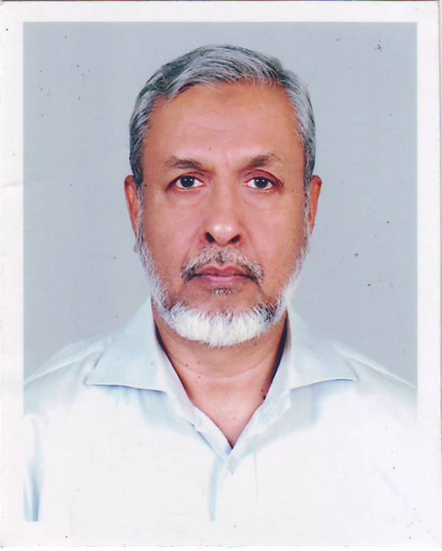  Engr. Syed Masud Hasan graduated in Mechanical Engineering (BUET) and obtained his Master Degree in Industrial Engineering and Administration from UK. He also received training at home and abroad in the different field of management namely Total Quality Management, Performance Improvement Programming, Social Accountability 8000, Maintenance Management, Systematic Problem Solving, Experiential Learning Approach, and Team Development etc.  Mr. Hasan has more than 40 years’ experience in Management Consultancy and Training. He joined Bangladesh Management Development Centre (BMDC) a leading institution in the field of Training, Consultancy and Research as a Management Counselor. He became Director of BMDC in 1991.  Currently, Mr. Hasan is the Managing Director of the Centre for Management Development, a well-recognized professional organization engaged in field of Management Training and Consultancy.  He was involved in many consultancy assignments under JICA, ILO, UNICEF, UNDP, World Bank, DFID and USAID funded and Dutch Assisted Projects. |  |  | Kaizen for Improving Organizational Performance  Introduction:  ‘Kaizen’ is Japanese management techniques renowned for improving organizational performance. The Japanese miracle in transforming the war ravaged country to an economic giant within a short span of time is attributed to this unique approach of concept and the techniques.  Kaizen is instrumental in increasing efficiency of performance. It contributes towards cost reduction and improvement of productivity and quality.  ‘Kaizen’ develops a mind-set for continuous improvement and brings the members in the organization to assume responsibilities in improving their work performance. Organizations adopting these techniques can achieve their goal successfully.  Course Objectives:  The ultimate aim of the course is to enable the participants to implement small changes in the organization for improvement. The course deals with ‘Kaizen’ techniques. At the end of the course the participants will be able to:  - Explain the concept of ‘Kaizen’  - Identify different steps for implementation of Kaizen  - Describe relevant problem solving tools for Kaizen  - Prepare Action Plan for implementing ‘Kaizen’ in their respective workplace.  Course Outline:  - Overview of Kaizen concept  - Approach and steps of Kaizen  - Problem Solving and QC Tools used in Kaizen  - Kaizen Action Plan  Nature of the Class:  Classes may involve lectures, videos, small group exercises, case analyses and discussions. Participants are expected to take part and contribute to discussions, and keep up with current issues of Kaizen.  Who will be Benefited?  The Course is designed for Senior, Mid and Junior level executives of different manufacturing, commercial and service organization both in public and private sector. Fresh graduates will also be benefited from the course.  Language: English and Bengali  Course Fee: BDT 4,000/- per participant (excluding VAT) payable in advance in favour of “Bangladesh Japan Training Institute” in the form of crossed cheque or pay order or direct deposit to” to Dutch Bangla Bank Ltd, Elephant Road Branch, Dhaka, Account Number: 1261100033403.  Or, via Bkash Pay (01780-364200) (you must pay an additional amount of BDT 80 Bkash cash out fee).  Members of BJTI, BAAS and organizations nominating five or more delegates will enjoy 10% discount on course fee. The fee will cover tuition, stationery, reproduction of training material, training aids/equipment, cost of venue, food & refreshment, certificate etc.  Note: Seats are limited and will be filled-in on first come first serve basis. Please find the attached file for Registration Form.
Certificate of attendance will be provided

