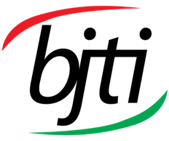 | BANGLADESH-JAPAN TRAINING INSTITUTE (BJTI)  is going to organize a  Day Long Exclusive Training on  Good Documentation Practice - Filing & Records Management  Resource Speaker: Mr. Moha. Rafiqul Islam, Ex - Executive Director, HR & Administration, Way Group

Date and Time: 31 May 2025 (Saturday), 08:45 am - 05:00 pm
Deadline for Registration: 29 May 2025 (Thursday)
Venue: Bangladesh-Japan Training Institute, Room # 7, 7th Floor, Eastern Plaza, Sonargaon Road, Dhaka.

Registration Fees: BDT 4,000/- Per Participant excluding VAT & TAX. (Members of BJTI, BAAS and Organizations nominating five or more delegates will enjoy 10% discount on course fee). The fee will cover tuition, stationery, reproduction of training material, training aids/ equipment, cost of venue, food & refreshment, certificate etc.
For Registration or additional information please call us: 01958-155162, 01958-155163, 02-223 361 413
or E-mail to: info@bjti.org, contact.bjti@gmail.com, Website: www.bjti.org, :https://www.facebook.com/bjti.info/
To confirm your registration, please fill out the registration form and pay the registration fee by 29 May 2025 (Thursday) in favour of “Bangladesh Japan Training Institute” to Dutch Bangla Bank Ltd, Elephant Road Branch, Dhaka, Account Number: 1261100033403.
Or, via Bkash Pay (01780-364200) (you must pay an additional amount of BDT 80 Bkash cash out fee).
Good Documentation Practice - Filing & Records Management

Overview:

Good documentation practice (GDP), also known as good record-keeping practice, is a set of internationally accepted guidelines that ensure the reliability, integrity, and veracity of data collected during the research, development, manufacturing and testing of drugs and medical devices.

Filling and Records management is vital to the delivery of our services in an orderly, efficient, and accountable manner. Effective records management will help to ensure that we have the right information at the right time to make the right decisions. It will provide evidence of what we do and why, therefore protecting the interests of the Organization. Records and the information we preserve are an important asset.

We aim to balance our commitment to openness and transparency with our responsibility as an effective regulator. So, we will create and manage records efficiently, make them accessible where possible, protect and store them securely and dispose of them safely at the right time. To support this policy, we will ensure that all staff receive appropriate records management training.

Course Contents:
- Introduction
4. Filing System
- Basic Filing Procedure
- Alphabetical
- Numeric
- Geographical
- Subject
- Chronologic
- Filing system in your computer.
- Definitions of:
- Record
- Electronic Record

- Good Documents Practice
- Principles of GDP
- Observation on Poor documentation process
- Benefits of GDP
- Documentation & Records:
- Documentation system and specification
- Equipment cleaning and use record
- Records of raw materials, labeling and
packaging materials
- Batch production and control records.
- Laboratory Control Records
- What is GDP practice in pharma?
- Document handling, preservation &
distribution.
- Records Management-
  - Benefits of electronic records
  - Challenges of Electronic records
  - Records Management
  - Electronic records Management
  - Electronic Records Keeping
7. Electronic records and electronic records keeping system
8. Business benefit of ERK
- Why records management is necessary?
- Document vs Records
- What is non records?
- Characteristics of Records
- Importance of Records
- Sources of Records
- Categories according to its usefulness
- Elements of Records Management
- Process of Records Disposal
- Archives
- Records Retention schedule

How participants will benefit after the course:
The participants will get benefit of: -
  - Records being easily and efficiently located, accessed and retrieved
  - Information being better protected and securely stored
  - Records being disposed of safely and at the right time.

The participants will be aware of: -
- The good documentation practices
- The creation of appropriate records
- The capture of records (received or created) in record
keeping systems
- The appropriate maintenance and upkeep of these
records
- The filing of the records
- The regular review of information
- The controlled retention of information
- The controlled destruction of information.

Target Group:

Office Secretary for MDs & CEOs, Personal Assistant and Private Secretaries, Front Desk Executive
Would-be Entrepreneurs, Business Executives from any business firm, Pharmaceuticals Companies, NGOs, Trust, Foundation and Other persons having special interest in filling and record management skills.

Training Methodology:
- Interactive Lectures

- Questions & Answers.

- Power Point Presentation

Language: English and Bengali
Resource Speaker
Mr. Moha. Rafiqul Islam has more than 39 years of experience in HR & Administration in Bank, Insurance Company, Garments Sector & Local and Multinational Group of Companies. He has a vast knowledge of conducting domestic enquiry in Local, International & Multinational Company since 1994. He was Principal Officer of Grameen Bank in 1995, Joint Vice President of Delta Life Insurance Co. Ltd. in 1998, Vice President, Administration of Pragati Life Insurance Company in 2000 and Asst. General Manager, Administration in Grameen Communication in 2006. He was HR Department Head of AK Khan & Company Ltd. Corporate Office, Dhaka. He was Group Head of HR (General Manager, HR) of Greenland Group. He has served as Manager, Administration in Linde Bangladesh Ltd. (Former BOC), a Multinational Company. He has worked as Employee Relations Advisor at Kazi Farms Group. He has worked as a faculty of Post Graduate Diploma Course on HR and ER & Compliance at Bangladesh Institute of Management Studies (BiMS). He has worked as Group Head of HR, Administration & Legal Affairs (General Manager, HR) at Arbab Group.
He has also served as Executive Director, HR & Administration at Way Group.

At present he has been serving as HR & Labor Law Consultant.
Mr. Islam obtained B. A (Hons), M.A degree from Dhaka University in 1986, Bachelor of Laws degree in 1992, MBA Degree in 2000 and Post Graduate Diploma in Personal Management in 2008 from BIM. He has attended in many Trainings & Conference both at home and abroad. He is a Fellow Member of Bangladesh Society of Human Resource Management, Institute of Personnel Management of Bangladesh, Professional Society of Bangladesh (PSB) & Life Member of Bangladesh Society for Total Quality Management.
He has been conducting training on Human Resource Management, Administration, Labor Laws, Civil & Criminal Laws, Logistics, Leadership Development, Legal Compliance, Safety & Security etc. arranged by bdjobs.com, Prothom aloe jobs.com, Dhaka Chamber of Commerce & Industry, Continuing Education Centre, IPDP, Business Express etc. He has worked as a Law officer with a lot of Attorney Generals, Barristers & Senior Lawyers to conduct the cases of both civil & criminal and service matters in Magistrate Court, Judges Court, High Court & Administrative Tribunals.

He is the Author of two books titled as “Disciplinary Action & Domestic Enquiry” and “Management Skills for HR & Administrative Professionals”.

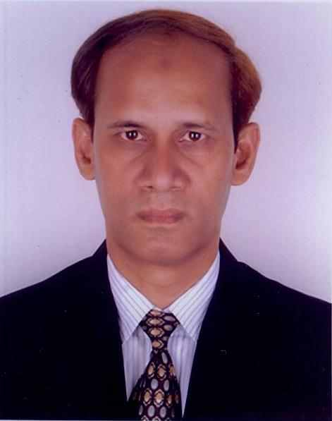

Reer

Mr. Moha. Rafiqul Islam
Ex - Executive Director, HR & Administration, Way Group

Certificate of attendance will be provided
Note: Seats are limited and will be filled-in on first come first serve basis. Please find the attached file for Registration Form.

