BANGLADESH-JAPAN TRAINING INSTITUTE (BJTI)
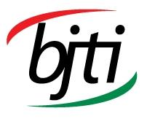

is going to organize a
Day Long Exclusive Training on
Guide to Mastering Supply Chain
Mr. Ibrahim Habib Rizwan, Sr. Manager, Supply Chain, Square Pharmaceuticals PLC
Resource Speaker:


17 May 2025 (Saturday)

Bangladesh-Japan Training Institute, Room # 7, 7th Floor, Eastern Plaza, Sonargaon Road, Dhaka.

08:45 am - 05:00 pm

15 May 2025 (Thursday)

Registration Fees: BDT 4,000/- Per Participant (excluding VAT & TAX), payable in advance in favour of “Bangladesh Japan Training Institute” in the form of crossed cheque or pay order or direct deposit to Dutch Bangla Bank Ltd, Elephant Road Branch, Dhaka, Account Number: 1261100033403 Or, via Bkash Pay (01780-364200) (you must pay an additional amount of BDT 80 Bkash cash out fee).
(The fee will cover tuition, stationery, reproduction of training material, training aids/ equipment, cost of venue, food & refreshment, certificate etc.)
For Registration or additional information please call us: 01958155162, 01958155163, 02-223361413
or E-mail to: info@bjti.org, contact.bjti@gmail.com, Website: www.bjti.org, :https://www.facebook.com/bjti.info/

Guide to Mastering Supply Chain

Introduction: In today’s fast-paced ever connected global market, the efficiency of supply chain can be the key differentiator between success and failure. Whether you’re looking to optimize operations, reduce costs, or stay agile in the face of disruption, mastering Supply Chain Management (SCM) is essential.
Our Day-Long Supply Chain Training Program is designed to equip professionals, freshers and students with the knowledge and tools to elevate supply chain knowledge performance. This program offers a dive into the core principles of SCM, covering everything from demand forecasting and inventory management to risk mitigation and technology integration.
Throughout the day, participants will explore real-world strategies like Lean and Agile SCM, learn how to manage supply chain risks, and discover the latest technologies driving efficiency and visibility in modern supply chains.

Course Objective: To provide participants with an understanding of supply chain management concepts, strategies, and tools to improve efficiency, reduce costs, and enhance competitiveness.

Course Content:
- Introduction to Supply Chain Management
- Definition and importance of supply chain management.
- Key objectives of SCM
- Supply Chain Components
- The supply chain process
- Role of suppliers
- Mapping and visualizing supply chain flows
- Supply Chain Strategy
- Supply Chain Planning
- Demand Forecasting & Management
- Inventory management techniques
- Supply Chain Risk Management
- Identify & Mitigate Supply Chain Disruptions
- Supply Chain Optimization
- Supply Chain Metrics
- Lean Principles & Techniques
- Supply Chain Optimization
- Technology in SCM

Who will be Benefited: This training is ideal for supply chain professionals, managers, and executives across industries who want to improve operational efficiency, reduce costs, and enhance their organization’s competitive edge as well as individuals looking to gain more insights into present day Supply Chains in practice. Students, freshers willing to have preliminary idea of Supply Chain will also be benefitted.

Training Methodology: Power point presentation, interactive sessions and real life examples.

Language: English and Bengali

Resource person
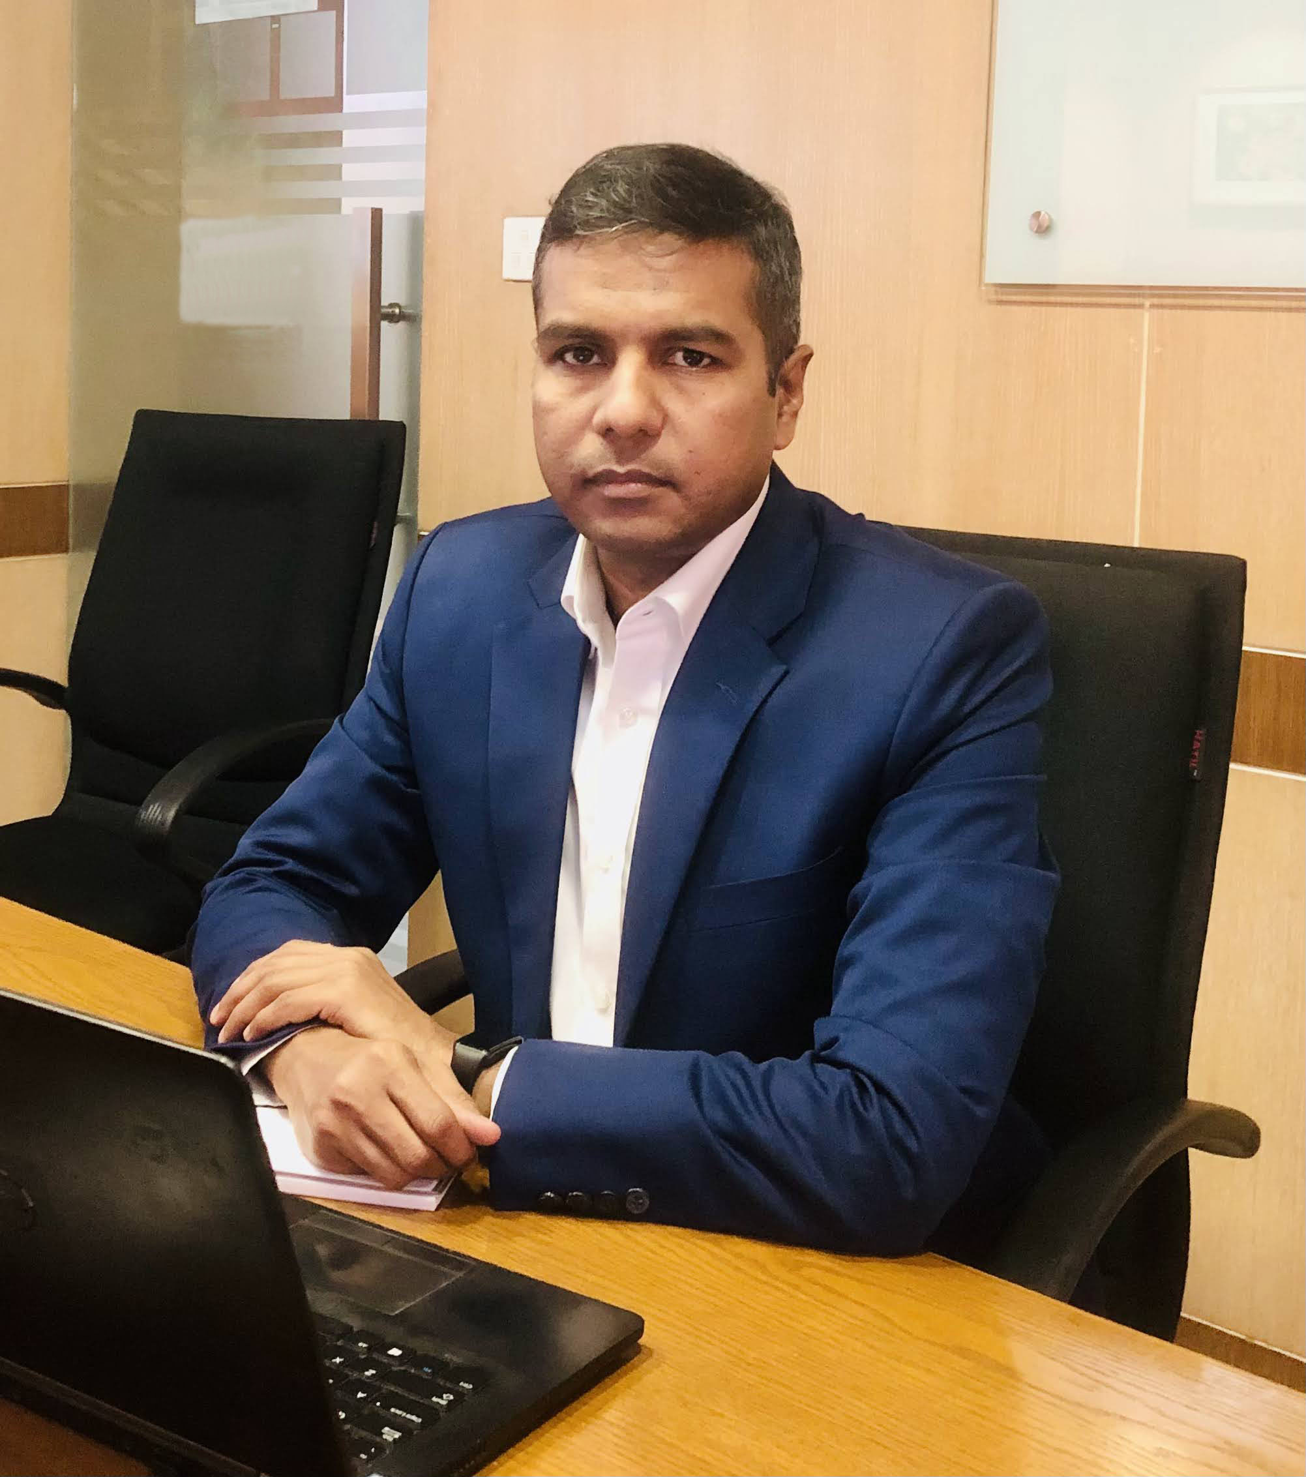
Mr. Ibrahim Habib Rizwan is a Supply Chain professional with over 16 years’ experience in the leading pharmaceutical company in Bangladesh. His expertise lies in managing supply of several hundred SKUs. Integral to his role is the meticulous planning, development, and execution of comprehensive supply plans, where he has efficiently navigated negotiation intricacies and financial, operational considerations, ensuring the seamless flow of both imported and locally sourced materials. His acumen extends to collaborative endeavors involving the launch of several brands, a testament to his commitment to process optimization. His academic qualification includes International Diploma in Supply Chain from the International Purchase and Supply Chain Management Institute (IPSCM). Additionally, he has pursued SALM (South Asian Logistics Management) training at the Toyota Kenshu Center (TKC) in Japan. He is also an MBA from MIST, Dhaka University.

Mr. Ibrahim Habib Rizwan, Sr. Manager, Supply Chain, Square Pharmaceuticals PLC

