 |  | BANGLADESH-JAPAN TRAINING INSTITUTE (BJTI)  is going to organize a  Day Long Exclusive Training on  Supervisory Skills Development Workshop  Resource Speaker: Mr. A.N.M. Shahjahan  Former Director of Human Resources, Director of Training, Dhaka Sheraton Hotel, Former General Manager Jamuna Resort Ltd., Coordinator, Skills for Employment Investment Program (SEIP) and Director, BJTI Board
Date | 16 November 2024(Saturday)  Time: 08:45 am – 05:00 pm | Last Date of Registration |  | 14 November 2024 (Thursday)
Venue | Bangladesh-Japan Training Institute, Room # 7, 7th Floor, Eastern Plaza, Sonargaon Road, Dhaka. | Registration Fees |  | BDT 4,000/- Per Participant excluding VAT. (Members of BJTI, BAAS and Organizations nominating five or more delegates will enjoy 10% discount on course fee). The fee will cover tuition, stationery, reproduction of training material, training aids/ equipment, cost of venue, food & refreshment, certificate etc.
For Registration or additional information please call us: 01958155162, 01958155163, 02-223 361 413
or E-mail to: info@bjti.org, contact.bjti@gmail.com, Website: www.bjti.org, :https://www.facebook.com/bjti.info/
To confirm your registration, please fill out the registration form and pay the registration fee by 14 November 2024 (Thursday) in favour of “Bangladesh Japan Training Institute” to Dutch Bangla Bank Ltd, Elephant Road Branch, Dhaka, Account Number: 1261100033403.
Or, via Bkash Pay (01780-364200) (you must pay an additional amount of BDT 80 Bkash cash out fee).
Resource Speaker  Mr. A.N.M. Shahjahan  Former Director of Human Resources, Director of Training, Dhaka Sheraton Hotel, Former General Manager Jamuna Resort Ltd., Coordinator, Skills for Employment Investment Program (SEIP) and Director, BJTI Board  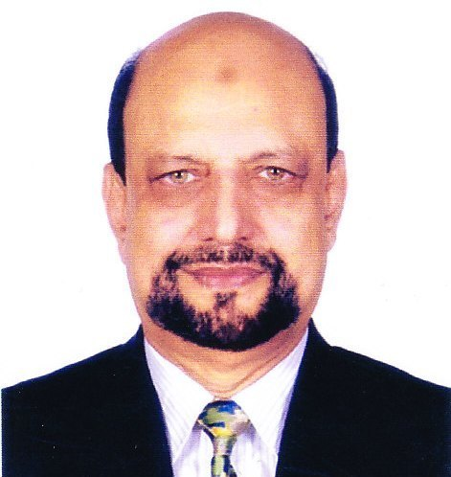  Mr. Abu Nayeem Md. Shahjahan obtained his Masters in Social Science (MSS) from Dhaka University; Bachelor in Hotel Management from Rome, Italy; Post Graduate Diploma in Personnel Management from IPM Dhaka.  Presently working as the General Manager of Space Apartments & Suites. He worked as the General Manager of Jamuna Resort, Director of Human Resources, Director of Training, and Director of Food & Beverage at Dhaka Sheraton Hotel.  Mr. Shahjahan is the Founder Director of Bangladesh-Japan Training Institute (BJTI). Mr. Shahjahan is the recipient of the President’s Award of Sheraton Overseas Management Corporation for his outstanding performance in the field of Training at Dhaka Sheraton Hotel. He attended numerous training on management skills both in home and abroad including USA, Italy, Japan, Hongkong and Thailand. Mr. Shahjahan has over 25 years’ experience as a professional Trainer.  Mr. Shahjahan is a former faculty of Hospitality management at IUBAT. He is a professional trainer at Bangladesh-Japan Training Institute (BJTI), DCCI Business Institute and a certified Assessor of Trainers at BTEB. |  |  | Supervisory Skills Development Workshop  Course Objectives:  On completion of the course, the participants will be able to:  - Improve Supervision skills effectively  - Learn the importance of training of associates  - Plan and organize day to day schedule  - Handling customer complaints  - Improve communication skills  - Enhance human relations  - Increase customer satisfaction  Course Outline:  - Define responsibilities of a Supervisor  - Effective supervision for quality management  - Japanese management style of supervision  - Human relations for effective team work  - Effects of reward and punishment on productivity  - Benefits of training associates  - Planning of 5Ms (man, money, machine, materials and method)  - Role of knowledge and skills for productivity  - Supervision Skills enhance Advancements  Nature of the Class:  Classes may involve lectures, small group exercises, case analyses and discussions and multimedia presentations. Participants are expected to take part and contribute to discussions, and keep up with current issues in their respective areas, exchange views and ideas with other organizations through rapport and inter-actions, encourage with success stories.  Who should attend the Course?  Managers, Department heads, Section in-charge, Mid-level Executives working in factories, Hospitals, Hotels, Tourism industries or any organization dealing with production of goods or services.  Language:  English and Bengali but slides and course materials will in English.  Certificate of attendance will be provided.  Course Fee: BDT 4,000/- per participant (excluding VAT) payable in advance in favour of “Bangladesh Japan Training Institute” in the form of crossed cheque or pay order or direct deposit to Dutch Bangla Bank Ltd, Elephant Road Branch, Dhaka, Account Number: 1261100033403.  Or, via Bkash Pay (01780-364200) (you must pay an additional amount of BDT 80 Bkash cash out fee).  Members of BJTI, BAAS and organizations nominating five or more delegates will enjoy 10% discount on course fee. The fee will cover tuition, stationery, reproduction of training material, training aids/equipment, cost of venue, food & refreshment, certificate etc.  Note: Seats are limited and will be filled-in on first come first serve basis. Please find the attached file for Registration Form.

