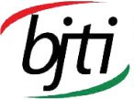 | BANGLADESH-JAPAN TRAINING INSTITUTE (BJTI)  is going to organize  Day Long Exclusive Training on  Self and Organizational Leadership Mastery: To unlock your Full Potential  Resource Speaker: Mr. Abu Al Tareq Ahmed  Soft Skills Activist & Trainer, Certified Talent Management Professional, Certified P-FIM Practitioner, Disability inclusion Practitioner
Date and Time: 15 November 2024 (Friday), 08:45 am - 05:00 pm
Deadline for Registration: 14 November 2024 (Thursday)
Venue: Bangladesh-Japan Training Institute, Room # 7, 7th Floor, Eastern Plaza, Sonargaon Road, Dhaka.
Registration Fees: BDT 4,000/- Per Participant, excluding VAT & TAX
For Registration or additional information please call us: 01958155162, 01958155163
or E-mail to: info@bjti.org, contact.bjti@gmail.com, Website: www.bjti.org, :https://www.facebook.com/bjti.info/
To confirm your registration, please fill out the registration form and pay the registration fee by 14 November 2024 (Thursday) in favour of “Bangladesh Japan Training Institute” to Dutch Bangla Bank Ltd, Elephant Road Branch, Dhaka, Account Number: 1261100033403.

Or, via Bkash Pay (01780-364200) (you must pay an additional amount of BDT 80 Bkash cash out fee). Members of BJTI, BAAS and organizations nominating five or more delegates will enjoy 10% discount on Training fee. The fee will cover tuition, stationery, reproduction of training material, training aids/equipment, cost of venue, food & refreshment, certificate etc

Resource Speaker  Mr. Abu Al Tareq Ahmed  Soft Skills Activist & Trainer, Certified Talent Management Professional,  Certified P-FIM Practitioner, Disability inclusion Practitioner  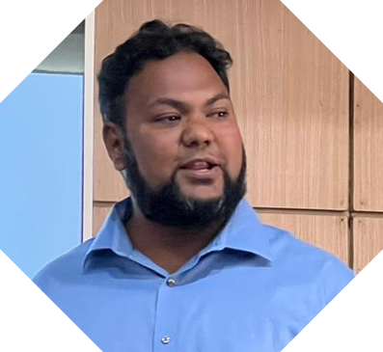  Mr. Tareq Ahmed is a well-known professional trainer, training consultant, soft skills activist and disability mainstreaming & inclusion practitioner in Bangladesh having more than 12 years of experience. He is an inspirational speaker, content writer, career coach, HR specialist and capacity building specialist. He is now working as a Project Manager and Capacity Building Coordinator in the Centre for Disability in Development (CDD) which is a development organization. Before this, he was head of training & development section, CRP. He has long time training facilitation experience including in the Rohingya Response, Cox Bazar, corporate training, development organizations and educational institutions. Besides his Training & Development career, he is a Certified Talent Management Professional (CTMP) which is accredited from the International Federation of Professional Managers (IFPM-UK). He has expertise in the capacity development of Individual, Group and Organizational Development (OD). He has different affiliations with different professional associations including BSHRM, FMCG HR Society of Bangladesh, BOLD, HR Professionals at Bangladesh, ISPO Bangladesh etc.  He has a good number of training consultancy experience including training module development for John Hopkings University of Communication Program, UNICEF, Edunyms Bangladesh, Memora Global etc. He is equally competent to training people in physical in person and online platforms. His one of the best-selling training course is Competency based Training of Trainer (TOT). He has a good number of training consultancy experience including training module development for John Hopkings University of Communication Program, UNICEF, Edunyms Bangladesh, Memora Global etc. | Self and Organizational Leadership Mastery: To unlock your Full Potential  Course objectives:  - To gain knowledge on self and organizational leadership,  - To enhance skills of self and organizational leadership,  - To engage employees and enhance productivity through effective leadership,  - To enable the participants becoming effective leader in the organization  Course contents:  - Understanding the thoughts of self and organizational leadership,  - Pillar of Self leadership and steps of becoming self-leader,  - Essential Elements of Organizational Leadership  - Powerful Ways to Influence People in a Positive Way  - How to Lead TEAM and conflict resolution?  - Effective Goal setting, Communication and Productivity improvement mechanism,  - Adapt or apply effective leadership style to meet specific challenges,  - Coaching to enable team members for high performance,  - How to be succeed as a LEADER: Interventions  - Emotional intelligence to establish leadership  Who can attend:  - Mid-level and/or first line management,  - Supervisors, line managers, team coordinators,  - Anyone who wishes to learn and develop organizational leadership skills  Training Methods:  - Lecture followed by discussion  - Brainstorming  - Group work & presentation  - Role play/simulation  - Storytelling  - Case study and Q-A  Language: English and Bengali  Certificate of attendance will be provided  Note: Seats are limited and will be filled-in on first come first serve basis. Please find the attached file for Registration Form.

