 |  |  | BANGLADESH-JAPAN TRAINING INSTITUTE (BJTI)  is going to organize a  Day Long Exclusive Training on  Productivity Improvement Techniques  Resource Speaker: Engr. Syed Masud Hasan, Managing Director, Centre for Management Development

Date and Time: 11 October 2025 (Saturday), 08:45 am - 05:00 pm
Deadline for Registration: 09 October 2025 (Thursday)
Venue | Bangladesh-Japan Training Institute, Room # 7, 7th Floor, Eastern Plaza, Sonargaon Road, Dhaka. |  | Registration Fees | BDT 4,000/- Per Participant excluding VAT & TAX. (Members of BJTI, BAAS and Organizations nominating five or more delegates will enjoy 10% discount on course fee). The fee will cover tuition, stationery, reproduction of training material, training aids/ equipment, cost of venue, food & refreshment, certificate etc.
For Registration or additional information please call us: 01958-155162, 01958-155163, 02-223 361 413
or E-mail to: info@bjti.org, contact.bjti@gmail.com, Website: www.bjti.org, :https://www.facebook.com/bjti.info/
To confirm your registration, please fill out the registration form and pay the registration fee by 09 October 2025 (Thursday) in favour of “Bangladesh Japan Training Institute” to Dutch Bangla Bank Ltd, Elephant Road Branch, Dhaka, Account Number: 1261100033403.
Or, via Bkash Pay (01780-364200) (you must pay an additional amount of BDT 80 Bkash cash out fee).
Resource Speaker  Engr. Syed Masud Hasan  Managing Director, Centre for Management Development  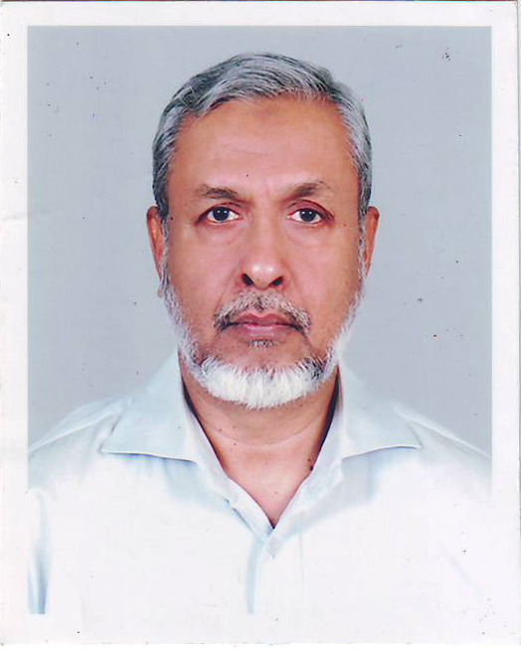  Engr. Syed Masud Hasan graduated in Mechanical Engineering (BUET) and obtained his Master Degree in Industrial Engineering and Administration from UK. He also received training at home and abroad in the different field of management namely Total Quality Management, Performance Improvement Programming, Social Accountability 8000, Maintenance Management, Systematic Problem Solving, Experiential Learning Approach, and Team Development etc.  Mr. Hasan has more than 40 years’ experience in Management Consultancy and Training. He joined Bangladesh Management Development Centre (BMDC) a leading institution in the field of Training, Consultancy and Research as a Management Counselor. He became Director of BMDC in 1991.  Currently, Mr. Hasan is the Managing Director of the Centre for Management Development, a well-recognized professional organization engaged in field of Management Training and Consultancy.  He was involved in many consultancy assignments under JICA, ILO, UNICEF, UNDP, World Bank, DFID and USAID funded and Dutch Assisted Projects. |  | Productivity Improvement Techniques  Introduction:  In this competitive business environment, every organization is striving for achieving competitive advantage by increasing their profitability. In order to increase profitability, it is imperative to improve the productivity of an organization. Productivity is a solid philosophy which helps to build competitiveness, confidence and smartness, leading to profitability.  Course Objectives:  At the end of the course the participants will be able to:  - Define and understand basic Productivity Concepts  - Understand Productivity Measurement Approaches  - Explain the different techniques for increasing Productivity in their Organizations  - Plan and manage effective Productivity Improvement Programs and activities in their organizations  Course Contents:  - Productivity: Definition and Concepts,  - Productivity Measurement,  - Productivity Improvement Techniques:  - Introduction to Work Study,  - Introduction to Work Measurement: Target Setting, Setting Performance Standards,  - Inventory Control,  - Value Analysis  Who Will Be Benefited?  Senior and Mid-Level Executives of industries and business organizations, Managers, Supervisors, Executives, Officers & other personnel involved in Operation, Sales, Production, Planning, Quality, Engineering, Training and anyone wishing to gain knowledge on productivity to increase their performance.  Methodology:  Conceptual Input with visual aids, Case studies, Video film and Discussion  Language: English and Bengali  Certificate of attendance will be provided  Note: Seats are limited and will be filled-in on first come first serve basis. Please find the attached file for Registration Form.

