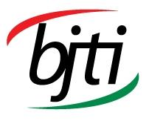 |  |  | BANGLADESH-JAPAN TRAINING INSTITUTE (BJTI)  is going to organize a  2 Days Long Exclusive Training On  Internal Auditor Course on ISO 45001 : 2018  Occupational Health & Safety Management Systems (OHSMS)  Resource Speaker: Mr. Mohammad Abdur Rahman. Specialist Trainer: Social &Technical Compliance, Writer: Compliance Series Book, Consultant: Social & Technical Compliance & Freelance Auditor: Social & Technical Compliance

Date and Time: 04-05 July 2025 (Friday & Saturday), 08:45 am - 05:00 pm

Deadline for Registration: 03 July 2025 (Thursday)
Venue | Bangladesh-Japan Training Institute, Room # 7, 7th Floor, Eastern Plaza, Sonargaon Road, Dhaka. |  | Registration Fees | BDT 7,000/- Per Participant excluding VAT. (Members of BJTI, BAAS and Organizations nominating five or more delegates will enjoy 10% discount on course fee). The fee will cover tuition, stationery, reproduction of training material, training aids/ equipment, cost of venue, food & refreshment, certificate etc.
For Registration or additional information please call us: 01958-155163, 02-223 361 413
or E-mail to: info@bjti.org, contact.bjti@gmail.com, Website: www.bjti.org, :https://www.facebook.com/bjti.info/
To confirm your registration, please fill out the registration form and pay the registration fee by 03 July 2025 (Thursday) in favour of “Bangladesh Japan Training Institute” to Dutch Bangla Bank Ltd, Elephant Road Branch, Dhaka, Account Number: 1261100033403.
Or, via Bkash Pay (01780-364200) (you must pay an additional amount of BDT 140 Bkash cash out fee).
Resource Speaker  Mr. Mohammad Abdur Rahman  Specialist Trainer: Social &Technical Compliance, Writer: Compliance Series Book, Consultant: Social & Technical Compliance & Freelance Auditor: Social & Technical Compliance  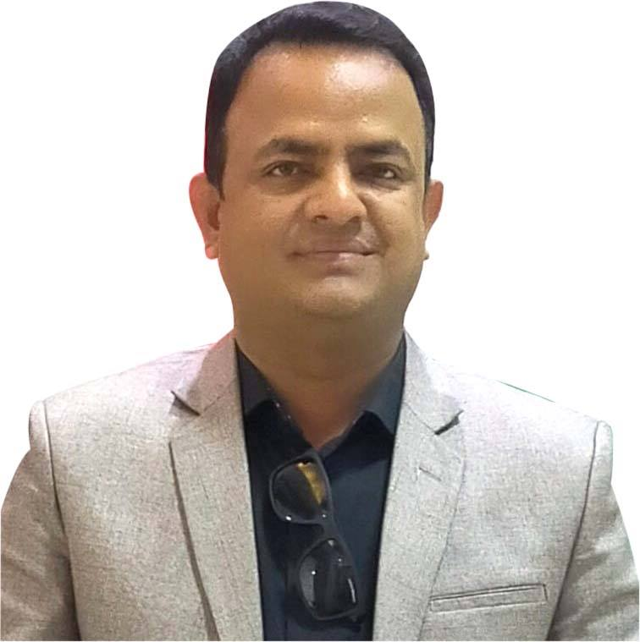  Mohammad Abdur Rahman served Compliance Sector for last 16 years in total 6(Six) renowned organizations in Bangladesh. Currently, he is the Managing Director & Consultant of “Compliance Consulting (BD) Limited’. He obtained B.Sc. (Honors), M.Sc. degree from Dhaka College, Dhaka under National University in 2000. PMBA (HRM) in 2014 from BIHRM and Post Graduate Diploma on HRM in 2011 from BIMS. He has a vast knowledge of conducting hands on compliance audit & consulting in compliance organization. He has attended in many Trainings & Conference on Compliance Management accordingly. He has completed the Internal Auditor Course on ISO 9001:2015 (QMS), ISO 14001:2015 (EMS), ISO 45001:2018 (OHSMS), ISO 22000 (FSSC 22000), SA 8000 Standards & so on & conducted internal audit of 12 years during his service life. He has successfully completed IRCA approved 5 Days Lead Auditor Course on ISO 9001:2015 (QMS), ISO 14001:2015(EMS) & ISO 45001:2018 (OHMSM). Now he is the freelance auditor of these standards accordingly.  He is a resource person in different country renowned training institutes/organizations. He is conducting a good number of social & technical compliance training including ISO Standards, International Social Standards, Labor Law, Labor Rules, and Compliance & HR Management. He is the 5 Days Social Compliance trainer in General Management Faculty & Industrial Compliance Trainer in Industrial Management Faculty, Marketing Compliance Management Training in marketing Management Faculty, Entrepreneurship Development Training in EDP & Financial Compliance in Finance Faculty of SCITI-BSCI, Uttara, Sector-6, Dhaka. He is the 2 days Labor Law & Labor Rules Trainer at SGS Bangladesh Limited (Ex Trainer). He is the Social & Technical Compliance specialist Trainer of Bdjobs Training Limited, BDBL Bhaban, Kawran Bazar, Dhaka. He is also the social & technical compliance specialist trainer of ADB & SEIP. He has trained over 5,000 new entrepreneurs, Compliance & HR Professionals, business owners, Foreigners, technical and management experts and still counting in. He is the renowned & most experienced consultant of social & technical compliance standards. He is physically involved in factory development for compliance certification audit. He is the most competent consultant of Sedex, Amfori BSCI, SMETA, WRAP, Bangladesh Labor Law 2006, ILO, GOTS, GRS,OCS, RCS, RSC, C-TPAT Compliance Standards, Buyer’s CoC, ISO 9001 (QMS), ISO 14001(EMS), ISO 45001(OHSMS), ISO 22000(FSMS), ISO 27001(ISMS) & so on.  He is the writer of Compliance Series Books which are the first time in Bangladesh. He has 10(Ten) books in compliance market now. |  | Internal Auditor Course on ISO 45001 : 2018  Occupational Health & Safety Management Systems (OHSMS)  Overview:  Internal auditing of OH&S Management System is a process that helps to improve working conditions and safety while minimizing risk. An effective internal auditor course on ISO 45001:2018-Occupational Health & Safety Management Systems can be the best learning tools to control & minimize the OHS risk accordingly. This course explains the implementation of ISO 45001 management system to control and improve the safety or occupational health and safety performance of an organization. It provides guidance in building the OH&S management system in support of an organization's processes, linking the management system to the requirements of ISO 45001:2018, to support third-party certification. Discover how you can prevent and reduce such occurrences at your workplace with the ISO 45001 Occupational Health and Safety Standard. This internal auditor course prepares learners to perform internal auditor activities, evaluate your organization’s OH&S management system for regulatory compliance, and draft quality reports while suggesting corrective actions.  Course Outline:  Module 01:  - Welcome & introduction  - Brief introduction to ISO  - Introduction to ISO 45001:2018  - Overview of the ISO 45001:2018  - Key changes in ISO 45001:2018  Module-02:  - Risk Based Thinking, PDCA Cycle and the Process Approach  - Understanding of Process and Risk-Based Approach  - ISO 45001:2018 Framework/Structure  - OHS Policy preparing techniques  Module-03:  - Leadership & Senior Management involvement in the OHS management systems  - Resource to implement OHS  - Incident, Nonconformity, Corrective action  - OH&S Objectives & risk reduction  - Outsourced Process Control (e.g: Contractor & Suppliers  - Hazard Identification & Risk Assessment (HIRA) Analysis  Module 04  - Principle of Internal Auditing  - Planning for the audit  - Conducting an internal audit  - Opening Meeting  - Auditors’ Responsibilities  - Do’s & Don’t of auditor  - Document Review  - Documenting Non-conformities  - Audit Review and Report Writing  - Presentation of Audit Findings  - Audit Report  - Closing Meeting  - Audit Follow Up  Nature of the Class: Interactive & Workshop  Who will be Benefited?  EHS, OHS, HR, Compliance professional, Anyone who intends to be a good Internal Auditor  Language: English and Bengali  Certificate of attendance will be provided  Course Fee: BDT 7,000/- per participant (excluding VAT) payable in advance in favour of “Bangladesh Japan Training Institute” in the form of crossed cheque or pay order or direct deposit to Dutch Bangla Bank Ltd, Elephant Road Branch, Dhaka, Account Number: 1261100033403.  Or, via Bkash Pay (01780-364200)  Note: Seats are limited and will be filled-in on first come first serve basis. Please find the attached file for Registration Form.

