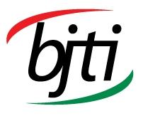 |  | BANGLADESH-JAPAN TRAINING INSTITUTE (BJTI)  is going to organize a  02-Day long Lab Session on  OKR Master Class  Resource Person: Mr. Md. Mostafa Kamal, SPP, SMPS, BSP, C-SBP, C-PA, C-KPIP, C-KPI Practitioner, C-OKRP, CPM, CRP, CTAP & CHRBP. Strategy, Process & PMS Consultant. CEO, Savvy Consultancy and Training
Date | 16 & 17 May 2025 (Friday and Saturday), Time: 8:45am - 5:00pm | Last Date of Registration |  | 15 May 2025 (Thursday)
Venue | Bangladesh-Japan Training Institute (BJTI), BAAS Centre, Room # 31-32, 7th Floor, Eastern Plaza, Dhaka. | Registration Fees |  | Tk 7,000/-Participant & USD100 (Foreigner) excluding VAT and TAX. (Members of BAAS and Organizations nominating five or more delegates will enjoy 10% discount on course fee.) The fee will cover tuition, stationery, reproduction of training material, training aids/ equipment, cost of venue, food & refreshment, certificate etc.
For Registration or additional information please call us: 01958155162, 01958155163
Registration Fees: BDT 7,000/- Per Participant (excluding VAT & TAX), payable in advance in favour of “Bangladesh Japan Training Institute” in the form of crossed cheque or pay order or direct deposit to Dutch Bangla Bank Ltd, Elephant Road Branch, Dhaka, Account Number: 1261100033403 Or, via Bkash Pay (01780-364200) (you must pay an additional amount of BDT 140 Bkash cash out fee).
(The fee will cover tuition, stationery, reproduction of training material, training aids/ equipment, cost of venue, food & refreshment, certificate etc.)
Resource Person  Mr. Md. Mostafa Kamal  SPP, SMPS, BSP, C-SBP, C-PA, C-KPIP, C-KPI Practitioner, C-OKRP, CPM, CRP, CTAP, TTT, NLP & CHRBP.  Strategy, Process & PMS Consultant.  CEO, Savvy Consultancy and Training  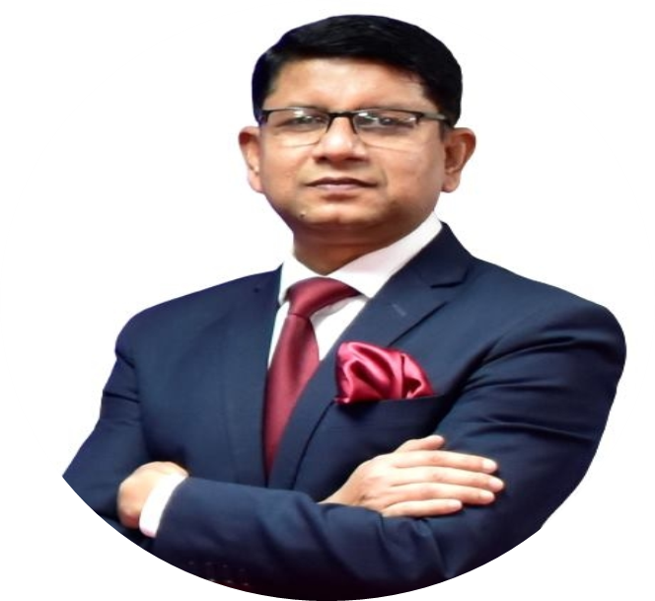  Mr. Mostafa Kamal working as Strategy, Process & Performance Management Consultant, Trainer and Strategic Planning Facilitator in the largest conglomerates in diverse field (Pharmaceuticals, RMG, FMCG, Engineering, Ceramics, Power, Paints, Capital Market, Real Estate etc.) with total experience of 35 years. Mr. Kamal is also CEO of Savvy Consultancy and Training, a pioneer in Integrated Strategic Planning and Performance Management System Consulting Firm in Bangladesh and beyond.  Professional Credentials:  - Advanced Organization Design Practitioner, Ashridge Hult Internation Business School, UK  - Certified OKR Professional, KPI Institute, Australia  - Scenario Planning Professional (SPP), The University of Western Australia  - Beyond Strategic Planning: From implementation to sustainment, Harvard University, MA, USA  - Strategic Business Management, Harvard University, Boston, MA, USA  - Balanced Scorecard Professional (BSP), BSI & George Washington University, Washington DC  - Strategic Management Performance System (SMPS), LBL & George Washington University  - Certified Strategy and Business Planning Professional (C-SBP), KPI Institute, Australia  - Blue Ocean Strategy Practitioner, Blue Ocean Strategy Institute, Melbourne, Australia  - Strategic Planning Facilitator, Institute of Cultural Affairs, USA  - Certified Process Manager, APQC, Houston, Texas, USA  - Certified Business Process Mapping & Improvement, UNSW, Canberra, Australia  - Certified Performance Audit Professional (C-PAP), Global Performance Audit Unit, Australia  - Certified KPI Professional (C-KPIP), KPI Institute, Australia  - Certified KPI Practitioner (C-KPI Practitioner), KPI Institute, Australia  - Assessor Capability Development Professional (ACDP), University of Cyberjaya, Malaysia  - Accredited Competency Professional, University of Cyberjaya, Malaysia  - Certified Reward Professional (CRP), Aon Hewitt, India  - Certified Talent Acquisition Professional (CTAP), Aon Hewitt, India  - Certified OD Developer (CODD), Carlton Advance Management Institute, India  - Certified Learning & Development Manager (CLDM), CAMI, India  - Certified Human Resources Business Partner (CHRBP), CAMI, India  - Train The Trainer (TTT), Bangalore, India  - Technology of Participation (ToP) Facilitation, Institute of Cultural Affairs, USA  - NLP, Onefluencer, India  Mr. Kamal has his own way to activate individuals with their unique style and link people with business strategy. Mr. Kamal possess an MBA-HRM, MA-English and PGD in HRM. |  |  | OKR Master Class:  Key Business Benefits:  - Improve the strategy execution of your company by identifying the main short-term objectives and key drivers of success;  - Obtain better business results by focusing on key stretched objectives for each quarter;  - Increase employee accountability by enabling them to practice OKRs alignment and by fostering flexibility.  Learning Objectives:  - Differentiate between Objectives Key Results and Initiatives;  - Recognize different types of OKRs;  - Acknowledge the benefits of stretched goals;  - Understand OKR setting in different contexts;  - Apply best practice techniques to align OKRs across the organization;  - Comprehend the review and decision making process;  Why OKR Based Performance Management System/Strategy Execution?  - Alignment of Goals: OKRs ensure that every department and individual’s efforts align with the overall company goals, creating unity in purpose.  - Focus on Priorities: By setting clear objectives, OKRs help teams and individuals focus on the most critical tasks that drive success.  - Transparency: OKRs are typically shared across the organization, allowing everyone to see the goals and progress of others, fostering openness and accountability.  - Measurable Progress: Key Results provide measurable targets, making it easier to track progress and evaluate success.  - Encourages Ambition: OKRs often encourage setting challenging goals, pushing teams to strive for ambitious outcomes beyond comfort zones.  - Improves Communication: OKRs facilitate clear communication about goals, making it easier for teams to collaborate and avoid misunderstandings.  - Adaptability: OKRs are typically set for short time frames (quarterly), allowing organizations to remain flexible and adjust to changing circumstances.  - Motivation and Engagement: Employees feel more motivated when they have clear goals and can see how their work contributes to the larger mission of the organization.  - Performance Tracking: OKRs help in continuous performance assessment, enabling quick identification of areas needing improvement.  - Promotes Innovation: By focusing on outcomes rather than just tasks, OKRs encourage teams to think creatively about how to achieve results.  Workshop Outline:  - Understanding OKRs  - What are OKRs?  - Stretched goals  - Measurable Key Results  - Action oriented initiatives  - OKR and other PMS  - OKRs vs KPIs  - OKRs and KPIs integration  - OKRS vs MBO  - Performance Management System based on OKRs  - Challenges in working with OKRs  - OKRs lifecycle  - The value added by OKRs  - Governance  - OKRs Typology  - Strategic vs tactical OKRs  - Aspirational vs Committed OKRs  - Setting OKRs  - OKRs setting process  - Common mistakes in setting OKRs  - OKRs setting in practice  - Aligning OKRs  - OKRs alignment approaches  - OKRs alignment in different types of organizations  - OKRs alignment in practice  - OKRs Review  - OKRs review process  - Types of OKRs review  - OKRs review in practice  - Learning from OKRs  - Decision making process based on OKRs  - Initiative management  - OKRs refinement  - Change Management Culture  - Change management  - Employee engagement  - Gamification  Methodology: Brain Storming, Case Study, Role Play/ Simulation, Lecture Discussion, Sharing/Participatory, Practical Problem Solving, Exercise.  Who will be benefited?  HR, Sales, Marketing, Operation, SCM and L& D Professional, preferably Executive to MD level.  Language: English and Bengali  Certificate: Certificate of attendance will be provided.  Note: Seats are limited and will be filled-in on first come first serve basis. Please find the attached file for Registration Form.

