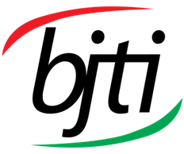 | BANGLADESH-JAPAN TRAINING INSTITUTE (BJTI)  is going to organize a  Day Long Exclusive Training on  Mastering Negotiation Techniques  Resource Speaker: Mr. Hasan Taiab Imam, Group Head, Human Resources of a large Group of Companies and Management Consultant, Adjunct Faculty of BiMS

Date and Time: 12 July 2024 (Friday), 08:45 am - 05:00 pm
Deadline for Registration: 11 July 2024 (Thursday)
Venue: Bangladesh-Japan Training Institute, Room # 7, 7th Floor, Eastern Plaza, Sonargaon Road, Dhaka.

Registration Fees: BDT 4,000/- Per Participant excluding VAT & TAX. (Members of BJTI, BAAS and Organizations nominating five or more delegates will enjoy 10% discount on course fee). The fee will cover tuition, stationery, reproduction of training material, training aids/ equipment, cost of venue, food & refreshment, certificate etc.
For Registration or additional information please call us: 01958-155163, 01958-155162, 02-223 361 413
or E-mail to: info@bjti.org, contact.bjti@gmail.com, Website: www.bjti.org, :https://www.facebook.com/bjti.info/
To confirm your registration, please fill out the registration form and pay the registration fee by 11 July 2024 (Thursday) in favour of “Bangladesh Japan Training Institute” to Dutch Bangla Bank Ltd, Elephant Road Branch, Dhaka, Account Number: 1261100033403.
Or, via Bkash Pay (01780-364200) (you must pay an additional amount of BDT 80 Bkash cash out fee).
Mastering Negotiation Techniques

Introduction:

Negotiation is not merely about getting what you want; it is about finding mutually beneficial solutions that satisfy the interests of all parties involved. Effective negotiation requires preparation, strategic thinking, clear communication and emotional intelligence. It is an art that blends psychology, communication and problem-solving skills to create value and build lasting relationships.
Recognizing that negotiation often involves conflict, this training provides strategies for conflict resolution and managing difficult conversations. You will also learn how to harness emotional intelligence to better understand and influence the emotions of others, facilitating smoother and more productive negotiations.
"Mastering Negotiation Techniques" is a valuable resource for professionals, business leaders and anyone seeking to improve their negotiation skills. Whether you are a seasoned negotiator or a novice, this training offers practical guidance and actionable strategies to help you achieve better outcomes in your negotiations.

Module Objectives:

1. Understand the fundamentals of negotiation.
2. Learn and apply different negotiation strategies.
3. Develop effective communication skills for negotiation.
4. Practice negotiation through role-playing exercises.
5. Enhance problem-solving and conflict resolution abilities

Training Module:
      - Introduction to Negotiation
      - Preparation for Negotiation
      - Negotiation Strategies and Tactics
      - Communication Skills in Negotiation
      - Conflict Resolution
      - Advanced Negotiation Techniques
Practical exercises and real-world examples are included throughout the training to help you apply the concepts and techniques in real-life situations. These exercises are designed to build your confidence and competence, enabling you to negotiate effectively in various contexts.
Happy Negotiating!

Language: English and Bengali
Resource Speaker

Mr. Hasan Taiab Imam is an HR professional with 12 years of experience. He is a speaker, motivator and business consultant. He has his MBA from one of the renowned private universities of Bangladesh with the highest academic award “The Summa Cum Laude” Gold medal. His Specialized Masters from Dhaka University on “Industrial Relations and Labor Studies” and LL.B has made him a much sought-after speaker. He inspires and informs people and helps them to realize their true potentials. His twelve years of understanding and experience has helped people on the path of professional achievement, career growth and personal fulfillment. Along with his HR career, for the past few years, Taiab has been invited to different private Universities and Management Institute to deliver lectures and conduct seminars. Taiab is the Associate member of “International Labor and Employment Relations Association”. Apart from it, Taiab has visited many countries like Switzerland, Germany, France, Malaysia, Singapore, China, Japan, United Arab Emirates and India. He has completed a scholarship program on “Solving Human and Organizational Problems-Teamwork and Leadership Skill Improvement “from “Ministry of Economy, Trade & Industry (METI)” of the Japanese Government.and many Operational techniques from German, Switzerland, Italy, Spain, China, Malaysia, Vietnam, Singapore etc. He is the Life and Fellow member of many National & Multinational HR & Management related organizations like- IMC, AOTS-HIDA, BSTQM, IPM, MBA club (NSU), HRPSB etc.

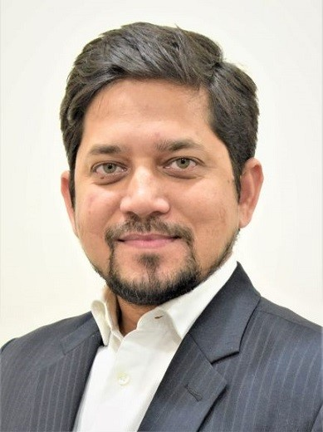

Reer

Mr. Hasan Taiab Imam, Group Head, Human Resources of a large Group of Companies and Management Consultant, Adjunct Faculty of BiMS

Certificate of attendance will be provided
Note: Seats are limited and will be filled-in on first come first serve basis. Please find the attached file for Registration Form.

